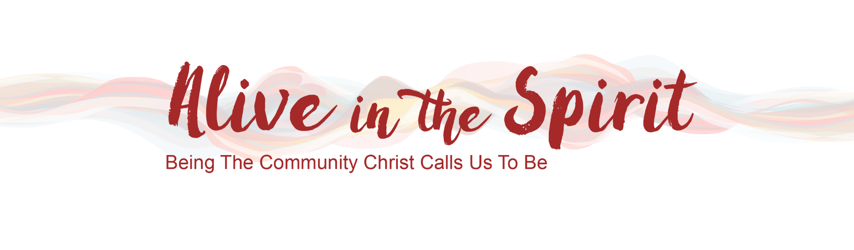
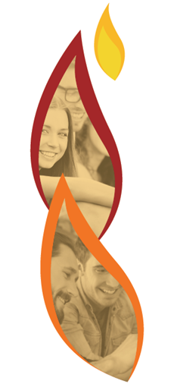
Media Kit
www.aliveinthespirit.com.au
8th – 10th July 2021
Virtual Conference
Reconnect, Renew and Reimagine
Community and Mission
Overview
Our faith communities are hungering for inspiration and support as we emerge from the pandemic and approach the first national plenary session. “Alive in the Spirit”, an innovative online conference, from 8 to 10 July 2021, offers a next-level experience to participants through a variety of keynotes, home-grown workshops and enriching prayer and worship experiences. The mixture of live and on-demand opportunities is fully adaptable to strengthen the mission and aims of local Catholic communities. www.aliveinthespirit.com.au
Press Release
https://aliveinthespirit.com.au/national-virtual-conference-to-enliven-catholic-communities/
About
Keynotes: Lana Turvy-Collins (Plenary Facilitator), Fr Richard Lennan (Professor of Systematic Theology, Boston College) and Leisa Anslinger (Associate Director, Pastoral Vitality, Cincinnati Archdiocese).
30+ on-demand workshops exploring areas such as best practice for RCIA, how we engage beyond the margins of our faith communities, planning for mission and renewal, supporting pastoral care, social justice initiatives and much more. Presenters are drawn from experienced pastoral ministers in Australia and New Zealand who offer practical, down-to-earth wisdom, resources and avenues of new life.
A variety of prayer spaces during the conference provide their own source of inspiration.
Exhibitors and one-to-one sessions with presenters. The conference also ensures a number of scheduled networking sessions to enable all participants a chance to share their wisdom and learn from others in the mission field.
Community Hubs: Support available to coordinate community hubs to engage with conference.
Hosted by: Three long-standing and wide-reaching Catholic networks: the Pastoral Ministry Network, Christian Initiation Australia Network and the Mission Planners Network Oceania.
Platinum Sponsors: Grief Care and the Diocesan Development Fund Parramatta. There are also a number of gold and silver sponsors.
Registration: individual - $40; community (5 or more) - $200
Audience
The conference offers inspiration and support to lay and clergy, staff, leadership teams, finance teams, pastoral councils, pastoral ministers and volunteers, chaplaincies, those in education, counselling, pastoral care, youth ministry, family ministry, aged care and anyone who wants to be Alive in the Spirit.
Share the Message
In the following pages you will find an array of advertising materials to promote the Alive in the Spirit Conference in your parishes, dioceses, faith communities, schools, offices, workplaces, bulletins, social media platforms … Wherever you would like to invite people to be Alive in the Spirit!
Follow us on Social Media
Like Alive in the Spirit on the following social media platforms and share these posts amongst your own networks.
Facebook: https://www.facebook.com/AitSConference
Instagram: https://www.instagram.com/AitSConference/
Twitter: https://www.twitter.com/AitSConference
Contact Us
If you would like original PDF’s or JPG’s of flyers or other graphics, or require something specific for your publications, please contact Lisa Bright at info@aliveinthespirit.com.au.
We will be posting updates on our website at www.aliveinthespirit.com.au. Keep visiting to stay up to date with the latest developments.

Media Assets
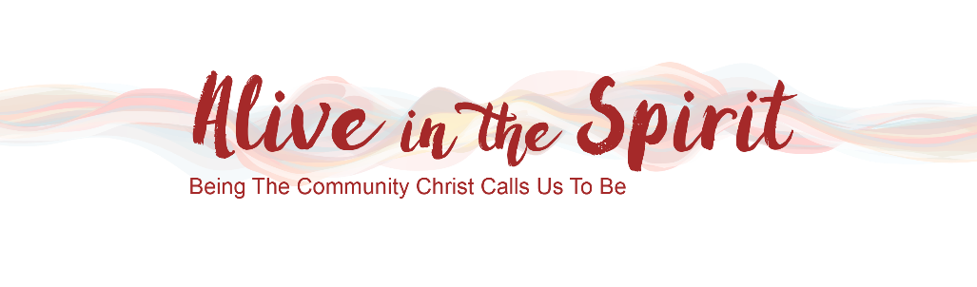
1. Logo and Footer

2. Videos
The 1 minute 39 second promo video is available here: www.aliveinthespirit.com.au
A Selection of short videos for websites, community promotion etc. is available:
www.aliveinthespirit.com.au/resources/

3. Community & Liturgy Resources
See page 5:
  - Newsletter Notice
  - Pulpit Notice
  - Prayer of the Faithful

Additional assets available in Parish Kit: www.aliveinthespirit.com.au/resources/

4. Posters & Flyers
Page 6 and 7

5. Banners, Tiles, Panels
Pages 7 to 11

Newsletters, Emails, Websites & Liturgy

Become Alive in the Spirit
Our parish is engaging in a special opportunity. “Alive in the Spirit”, is an innovative online conference, from 8 to 10 July 2021, which will enliven and inspire our community through a variety of keynotes, workshops and enriching prayer and worship experiences. We will be gathering together to view live sessions, and then small groups will select their own choices among the many workshops. Each small group will also debrief and share their insights together, bringing their wisdom back to the larger group.
This is an amazing opportunity to enrich your faith and inspire and resource us in serving God’s mission. To register *****************

Discover, Enrich and Make a Difference
Be part of a special opportunity. “Alive in the Spirit”, an innovative online conference, from 8 to 10 July 2021, which will enliven and inspire our community through a variety of keynotes, workshops and enriching prayer and worship experiences. We will be gathering together to view live sessions, and then small groups will select their own choices among the many workshops. Each small group will also debrief and share their insights together, bringing their wisdom back to the larger group.
This is an amazing opportunity to discover more about God, and ways to enrich our faith and make a difference in our world. To register *****************

PowerPoint Slide
See www.aliveinthespirit.com.au/resources

Message to Share at Mass or Community Lead Up Event/Meeting
[Play promo video]
[PowerPoint Slide]

Our parish is engaging in a special opportunity. “Alive in the Spirit”, an innovative online conference, from 8 to 10 July 2021, which will enliven and inspire our community through a variety of keynotes, workshops and enriching prayer and worship experiences. We will be gathering together to view live sessions, and then small groups will select their own choices among the many workshops. Each small group will also debrief and share their insights together, bringing their wisdom back to the larger group. This is an amazing opportunity to enrich your faith and inspire and resource us in serving God’s mission. To register *****************

Prayer of the Faithful
We pray for our Alive in the Spirit Community Experience:
May our engagement in the Alive in the Spirit Conference offer new vision, new energy and new life to all who participate. Lord, hear us.

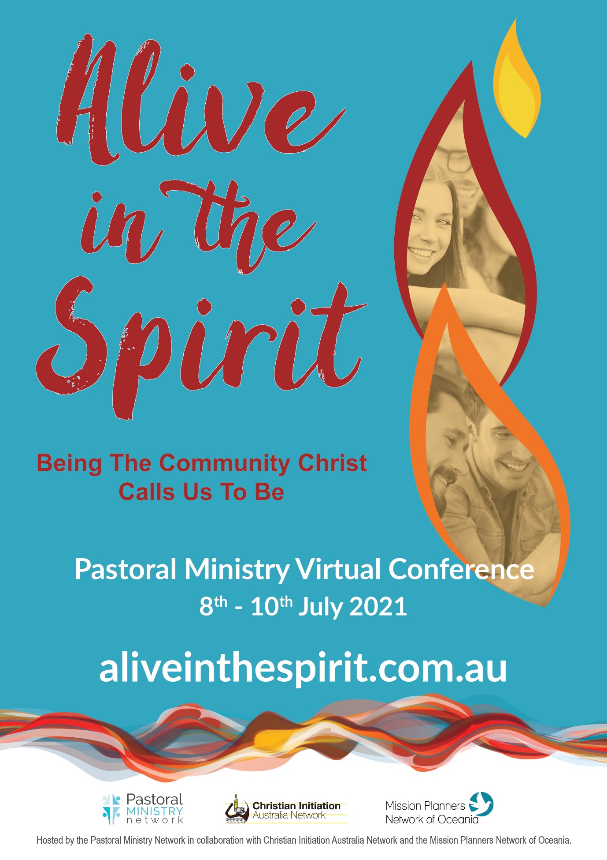
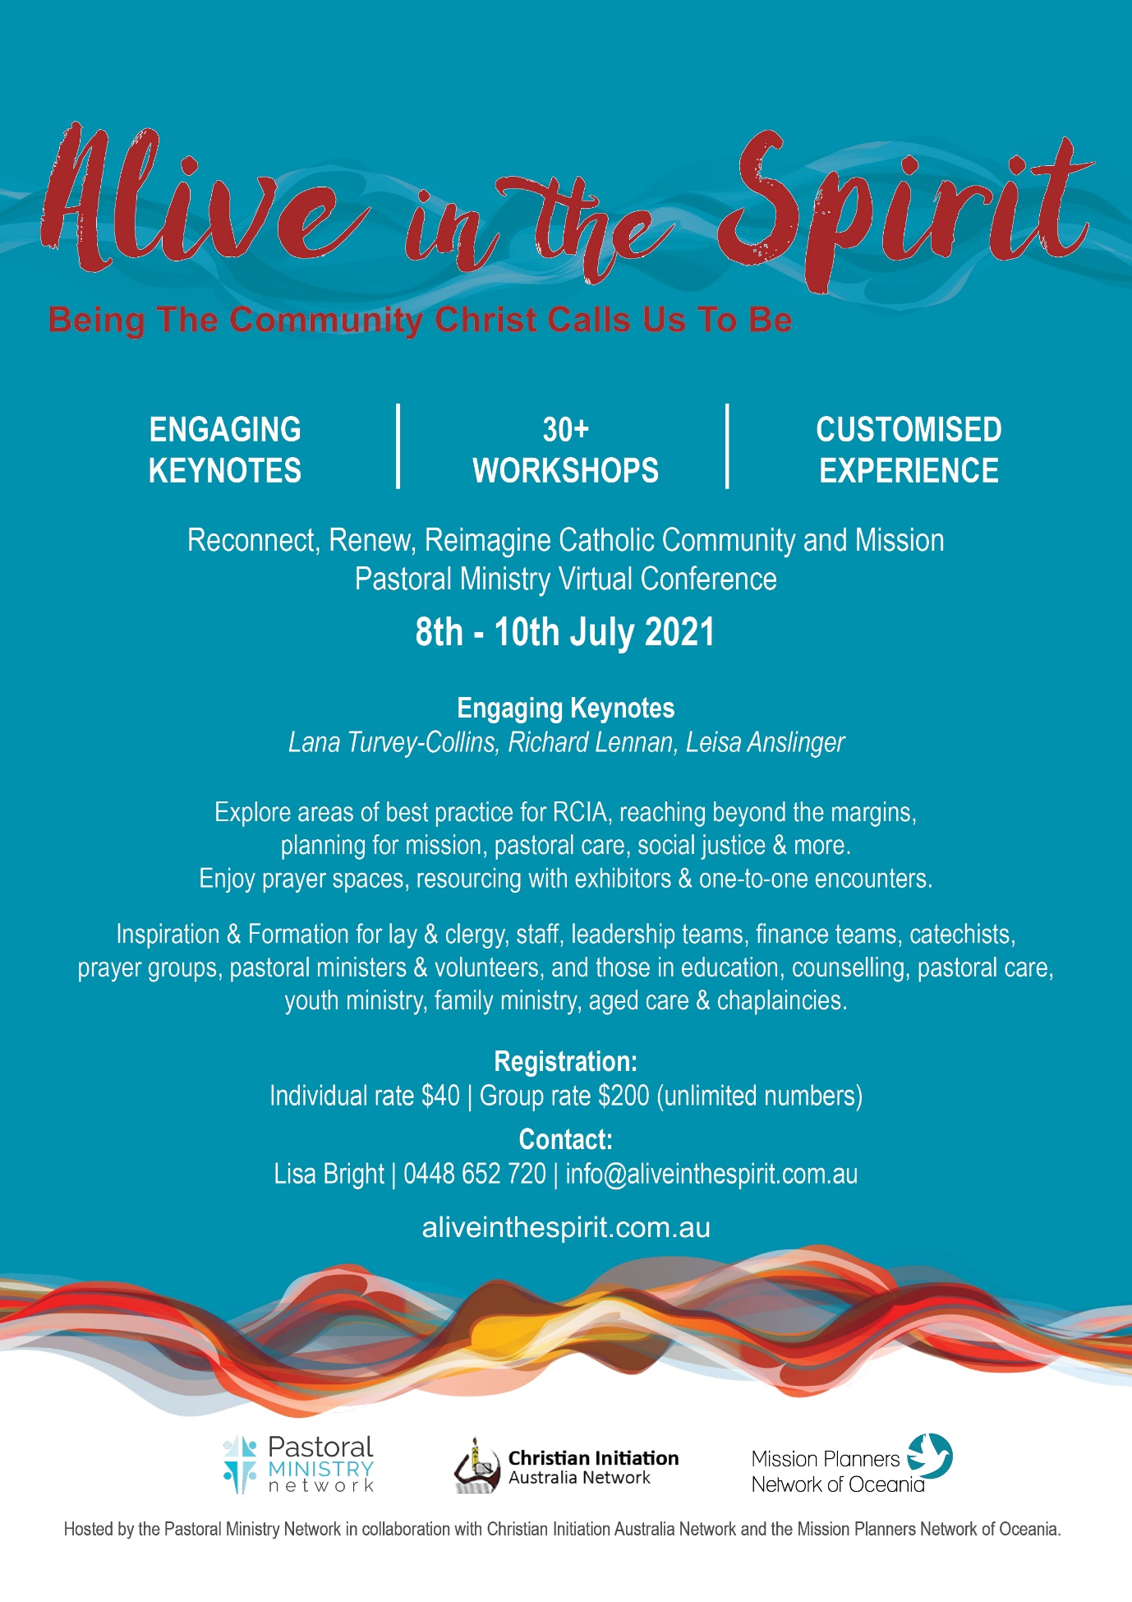

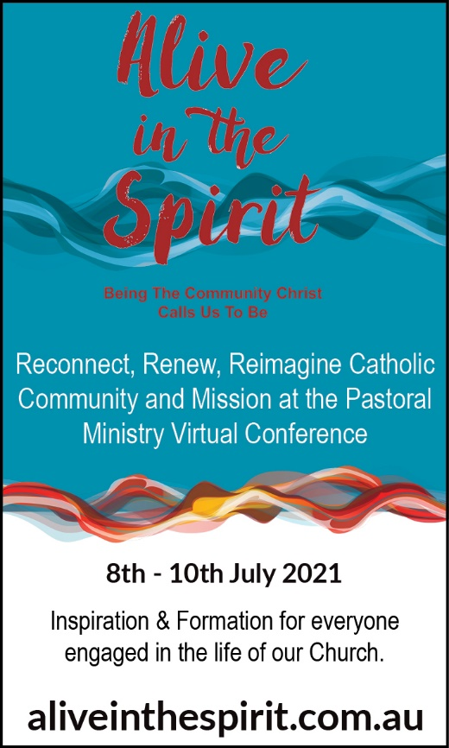
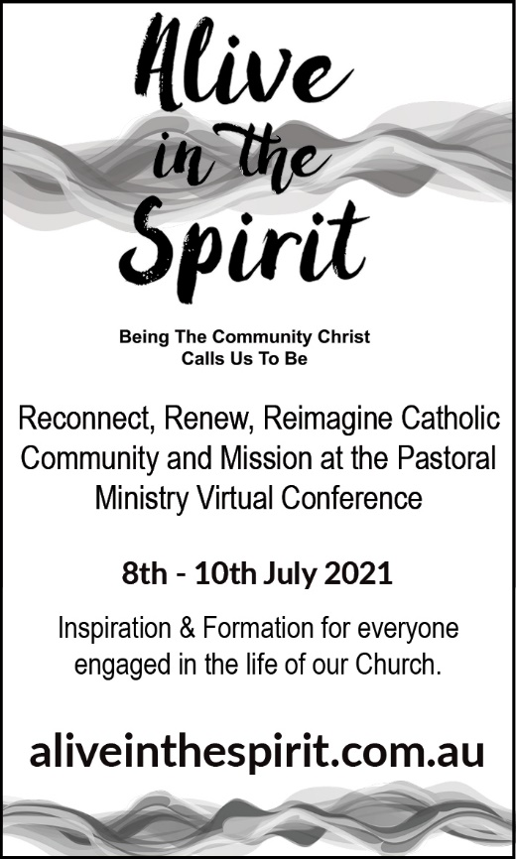
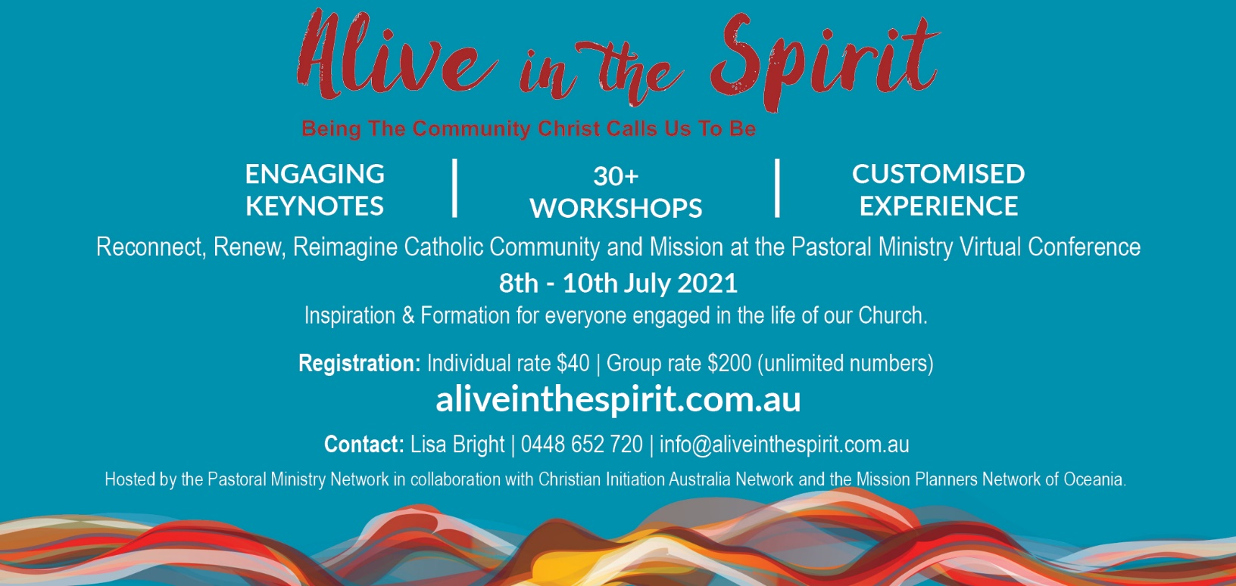
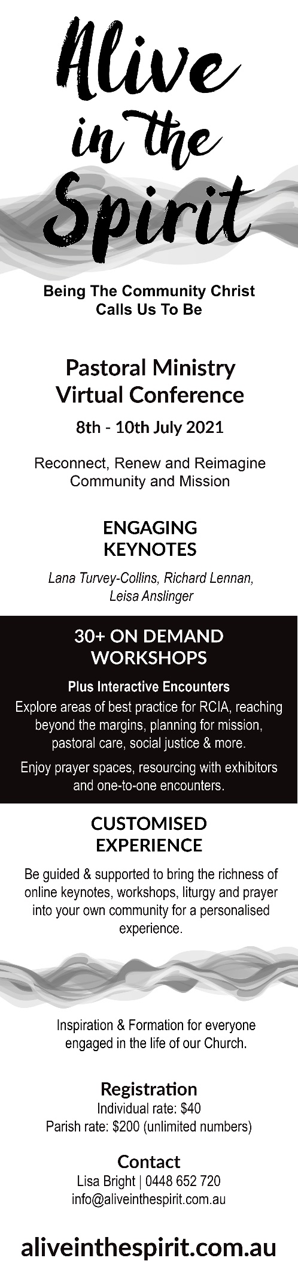
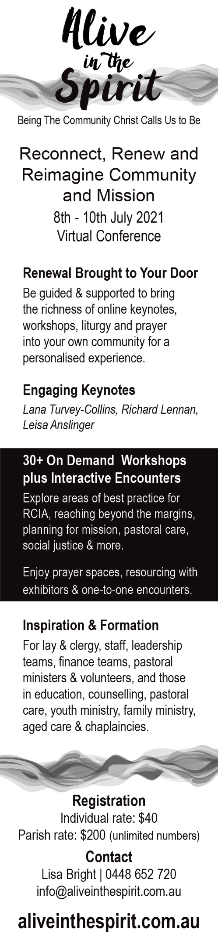

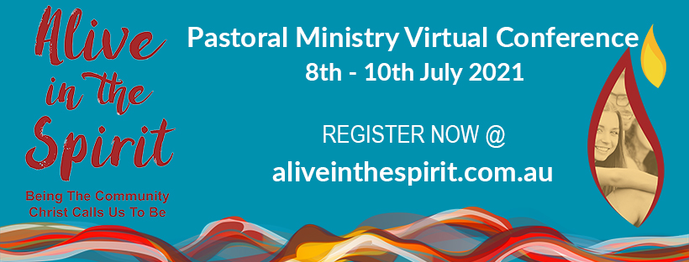

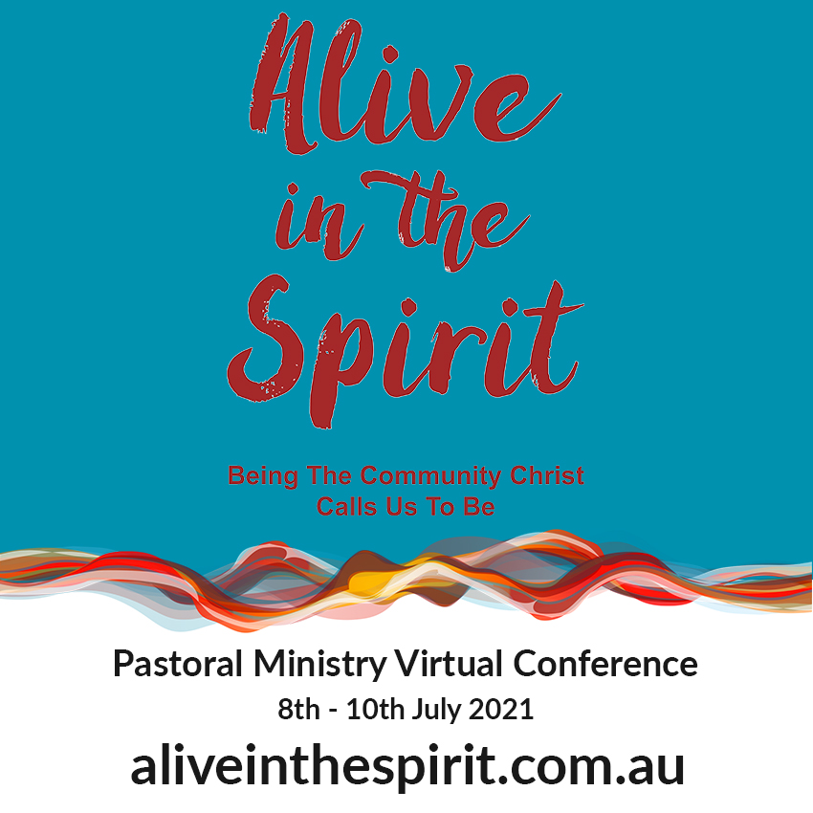
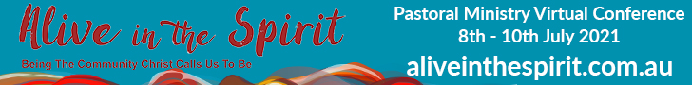
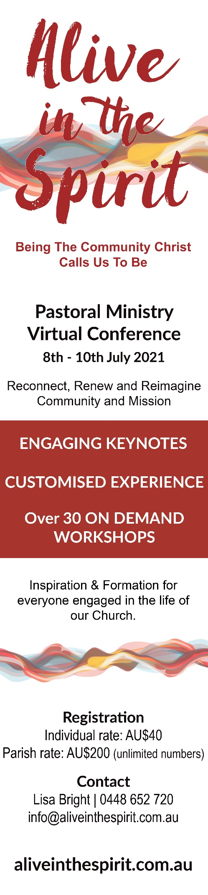
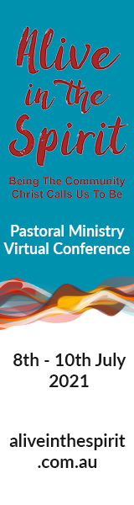
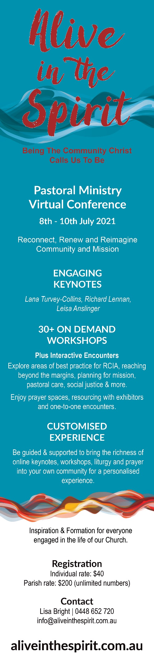
Alive in the Spirit
Virtual Conference
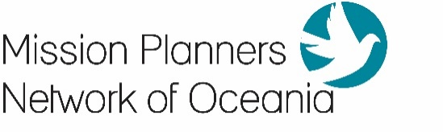
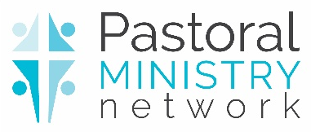
www.aliveinthespirit.com.au
Proudly hosted by: for GST

For all media enquires please contact Lisa Bright on 0448 652 720.

